Meeting the brief
My design for the game “Connect 4” meets my objectives as follows: It consists of 3 main game modes: single player, multiplayer and simulation play. The simulation plays 2000 games every time it is run. It also tests 2 hypotheses:
1st “What if the player only played in the 3 centre columns?”
2nd “What if the player only played in the last 4 columns?”
The results from these simulations are saved in a CSV database file. This data is then analysed using algorithms to calculate win rates, slopes and chance of draws to provide the player with predictions if they choose to play with a strategy. The data is also represented visually using “pandas” and “matplotlib”. The slope of the graph is taken and then inversed to find the average amount of moves needed to win per game, for each strategy. Both of these strategies are playable in the single player mode. Unfortunately, due to time constraints I was unable to implement the strategies into multiplayer.
Algorithms:
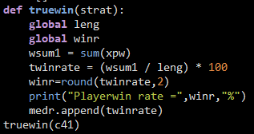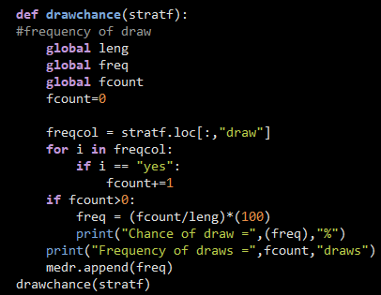
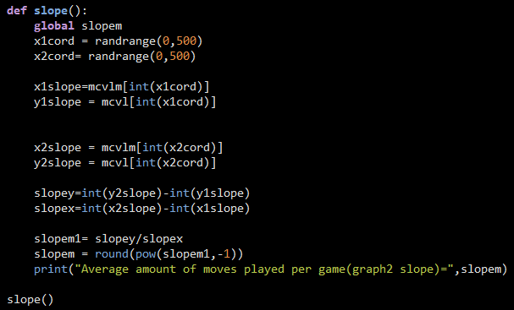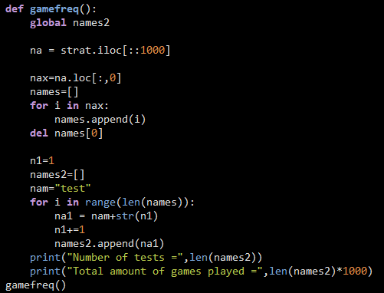
The game will only accept valid email addresses (i.e. the username and domain must be at least 3 characters long, and there must be at least one “.” and “@” ). The game will ask the gamemode the player(‘s) would like to play in. In single player the user will have the choice to play with a strategy, and then the player(‘s) will play until the game ends. If an unexpected input is received then the game will ask again for the correct input instead of crashing. This is achieved through the use of while loops.
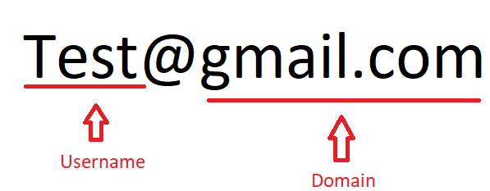
The game outputs a board which shows every move played by the players. When the simulation is run, the board is written to “Connect4 Board.txt” this ensures that the programme doesn’t crash when the simulation is run. This is done through the use of lists. I also utilized ANSI colour codes in order to break up the text and make it easier for the player to understand the instructions and prompts.
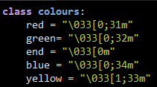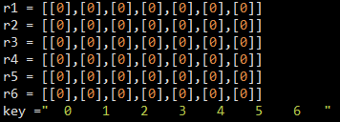
At the end of every game, the player(‘s) win rate calculated from previous games is displayed. The win rate displayed is calculated using the games played with the strategy the player is currently playing with (i.e. if a player plays using strategy 1, the win rate displayed will be calculated using only the games they’ve previously using strategy 1) .
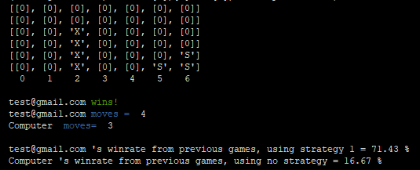

Investigation and plan
For my project I mainly conducted secondary research online. I desire to select a game which is fun, easy to understand and one that I have played before. I came across many games such as blackjack, noughts and crosses, ludo and many more. However, I decided to settle on the game “Connect 4”, not only is this a game I have played with my friends and family but one that is relatively simple to play. In my opinion, the games “Blackjack” and “Ludo” would have been too complex for someone who had never played them before. Whereas, noughts and crosses would’ve been too simplistic. I researched many websites however, I had to ensure the information was trustworthy. Connect 4 consists of a 6x7 board, in which two players compete to be the first one to connect four counters in a row, whether that’d be horizontally, vertically, or diagonally. The primary target audience for my game would be older children and teenagers who are interested in problem solving and strategizing games. In online implementations of Connect 4, the game usually consists of quite simplistic graphics such as red and blue counters and a simple board. The player is requested to input the column they wish to drop their counter in, and then an AI or 2nd player also drops a counter. The key factors needed in my implementation of my game are; the input from the player, algorithms and combinations needed to check if a player has won the game, a simple ai that can place a counter in a random column. The main features I will abstract away are; the graphics, as they aren’t necessary in the function of the game and the creation of a complex ai. The primary objectives of my game are: 1. A game that is fully interactive, can be played as single or multiplayer, can be completed and a win or a draw can be achieved. 2. It can take in multiple inputs such as email addresses, the column the player wishes to play in, game mode and strategies. 3. Game has single/multiplayer, a simulation can be run, in which the game is run by ai, strategies and hypothesis can also be tested. The simulation can run 2000 games within a matter of seconds and output the total number of wins, moves and draws. 4. The game is always random and is played differently every time. 5. Hypothesis and predictions such as only playing in the middle, or the last 4 columns can be tested. 6. The game will also display a board in which the players and opponents moves are shown.

Design
The design for my game follows the top-down design. User inputs are at the top . Core game-functions are in the middle. The end contains print statements that display the winner, moves played and code to output data to a database.
Objectives:
- 1st: Model is interactive. Players input their email address (emailcheck function) and the gamemode at the beginning. They choose a strategy, then the players enter their positions ,(“pos” function). In singleplayer, opponent moves are random and placed in different positions. Once a player connects 4 counters in a row they win, or if neither connect 4, the game draws.
- 2nd: The game accepts 3 inputs.
- Email addresses. The address is validated through the “email check” function, it checks for “.” and “@”. If it is invalid the programme asks again.
- Gamemode select, the user enters “0” for singleplayer or “1” for multiplayer. If multiplayer is chosen, the programme asks for player 2 to input their email address.
- Position input. This is an integer between “0”and “6”, if input is invalid, the player’s asked to input again. The “pos” and “board” function place and display the position on the board.
- 3rd: The game is playable in multiplayer and singleplayer or simulation. In singleplayer the player plays against a computer, multiplayer allows for 2 people to play. The simulation tests 2 hypothesis and runs 2000 games within seconds. This data is stored in a database.
- 4th: The game stores data to a” CSV” database file everytime it is run. It stores data such the email addresses, the winner, moves played and amount of draws.
- 5th: I have developed algorithms to calculate the average win rate of each strategy, average amount of moves needed to win and the frequency of draws which are used to predict the chance of draws. These are in the functions: “truewin”,” averagemoves” and” drawchance”. When the analysis is run, data is read from the “Connect4 hypothesis 1/2” CSV file, the data is analysed and using pandas, graphs are made. These highlight the relationship between the amount of moves and wins and the efficiency and effectiveness of the strategy.
The simulations test 2 hypotheses,
- 1st: “What if the player only played in the 3 centre columns?”
- 2nd: “What if the player only played in the last 4 columns?”
- 6th: A board displaying the players’ positions can be displayed using “board()” function. This creates a visual representation and makes the game more interactive and easier to understand.
My code is an abstraction as it contains no graphics or complex/trained AI. It has all the essential features like win check, and a counter placer.
Implementation
In the implementation, I utilized the agile approach, as I had to constantly go back and change or add on to previous code. I started off by creating the base game, I then moved on to multiplayer and the simulation. After meeting the basic requirements I went back and optimized/debugged the code before meeting the advanced requirements. After this, I had to go back to the single and multiplayer game in order to add in code for it to be able to read and write data to and from CSV files.
I begun with researching different games I could base my model off. I decided to go with Connect 4. I played multiple ports of the game online. I decided to start off with single player. Firstly, I coded the game to the basic requirements, such as the board, win checker .The game was fully playable to the end and interactive. Next I coded the simulation. It could run the game 2000 times in seconds but was not testing a strategy yet. After midterms, the simulation was coded up to the advanced standard, it was now able to test 2 hypotheses. The data was collected and stored in a CSV file. Using the algorithms that I made to calculate win rates and other averages, I was able to analyse the data and make predictions for each strategy in the game. The game was then completed to the advanced standard (i.e. the game now had a functioning email checker and was able display predictions and data from previous player games). Data was being collected every time it was run. Finally, I tested the game using black box and function testing. After fixing any bugs the game was finished and ready for submission.
One of the major problems I had with my code, was the fact that it was too long. This caused the program to unexpectedly crash or run too slowly. I spent days trying figure out what the issue might be until I realised it was the length of the code. This significantly slowed down my progress as I fell behind my classmates. I looked into this issue and how other games are programmed and structured. I realised that I needed to use functions. After I learned how to use functions, I optimised my code and cut it down by almost half through the implementation of functions.
The win check functions in my code are essential as they allow the game to be played to completion. Without them the game would never end. The functions simply look for a player counter in one of the lists and then using nested if-else statements, check the next 3 slots behind, in front, horizontally, vertically or diagonally. If 3 other counters are found then the game ends by meeting
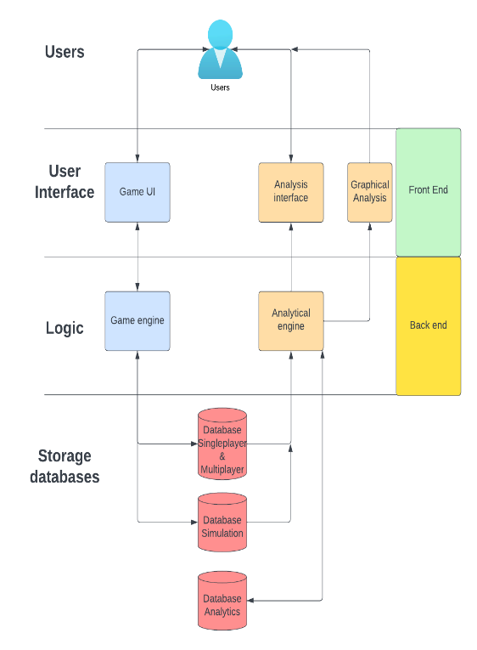-system architecture diagram 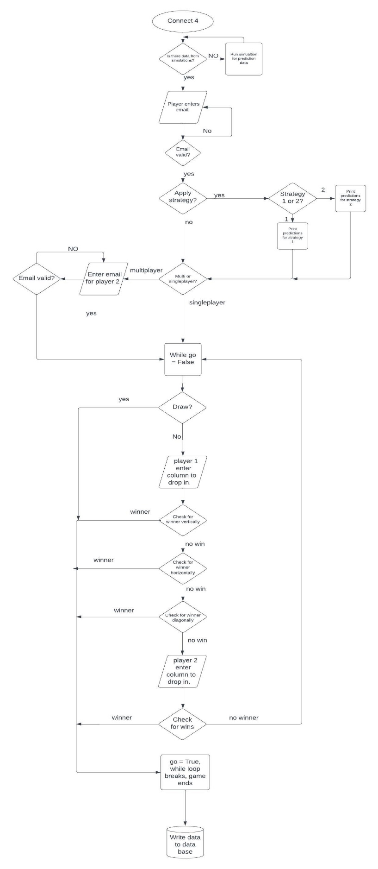
-Flowchart (Single / Multiplayer)

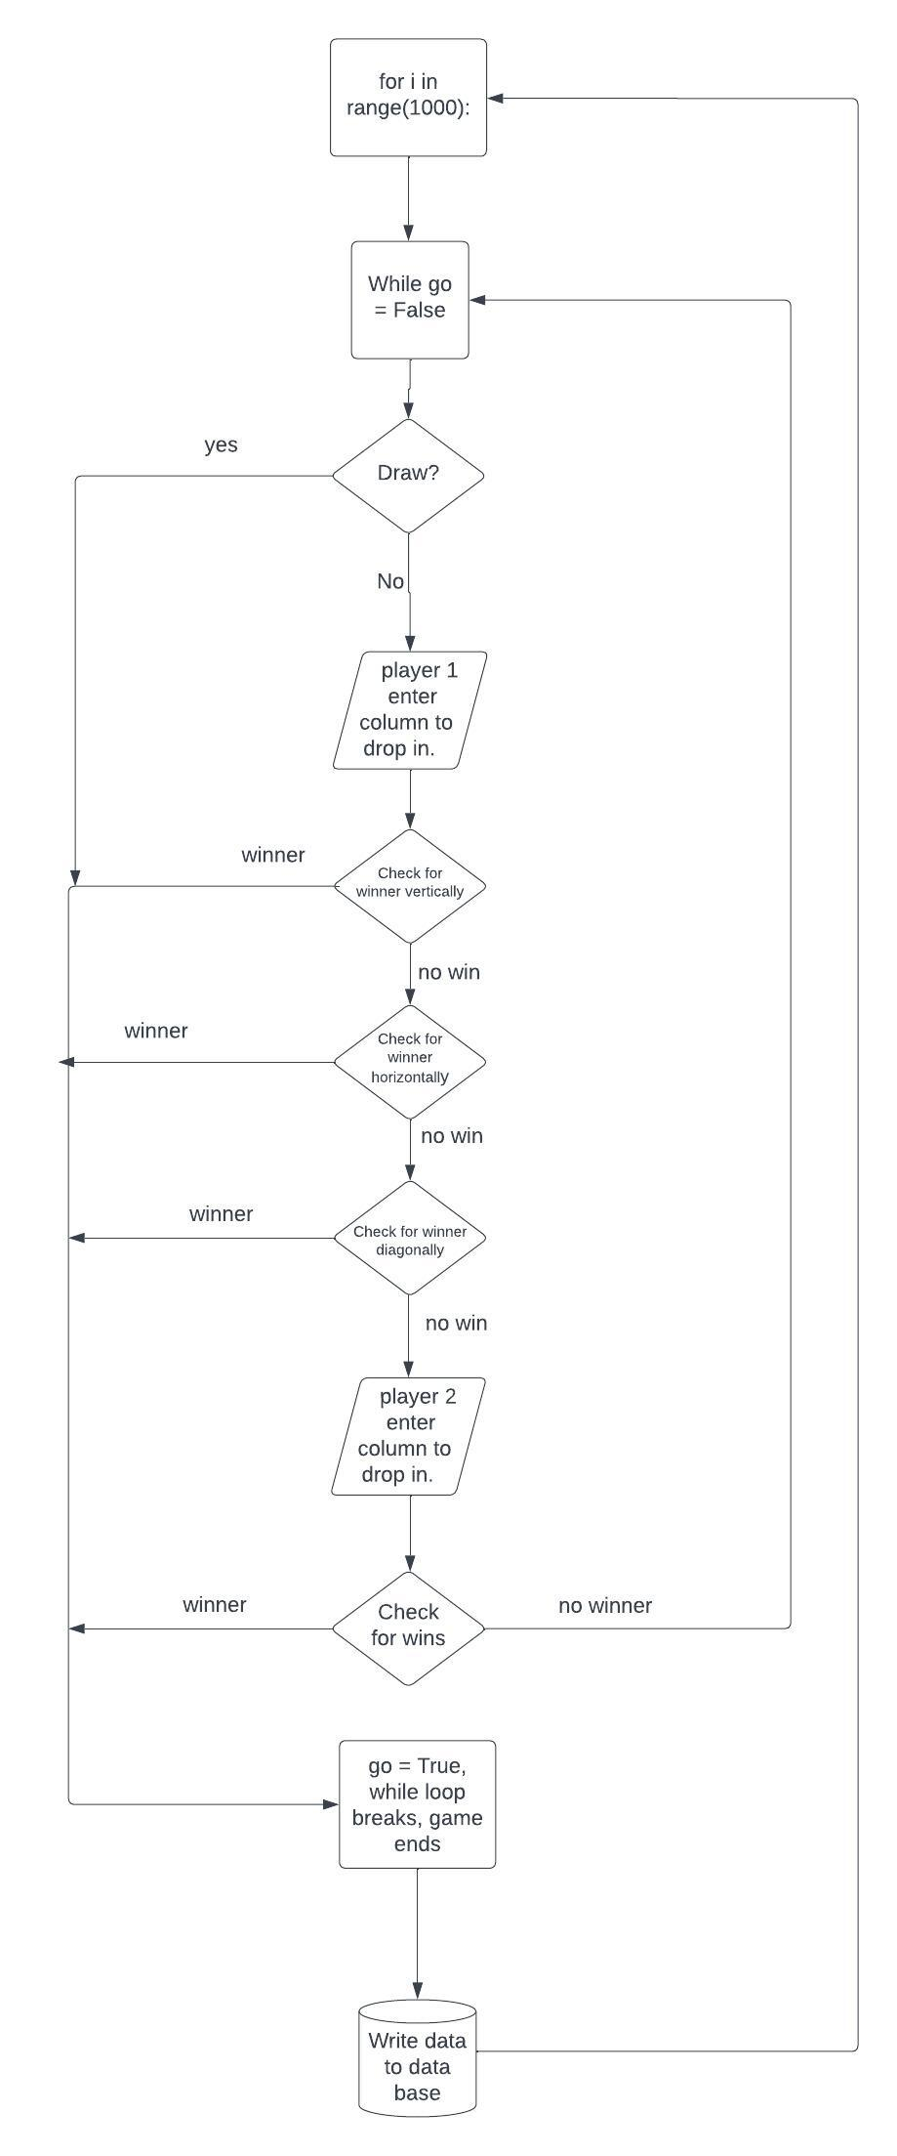Flowchart (simulation)
Testing
I utilised 3 main types of testing: functional, white box and integration testing.
During functional testing, I wrote driver code for 3 functions: Email checker, draw checker and horizontal win
“Emailcheck()” function:
Test Data | Expected result | Actual result | Pass? (y/n)
"t" | invalid | invalid | Y
".test@com" | Invalid | valid | N
"test@gmail" | Invalid | invalid | Y
"test@gmail.com” | Valid | valid | Y
"gmail.com" | Invalid | invalid | Y
".com" | Invalid | invalid | Y
“test@" | Invalid | invalid | Y
"test123@outlook.ie" | valid | valid | Y
"@" | Invalid | invalid | Y
"." | invalid | invalid | Y

Conclusion: There were adjustments needed in the function to ensure that there is at least one “.” After the “@”. This was done by ensuring that the index of “@” was less than the index of “.” and also ensuring the length of the address was correct.
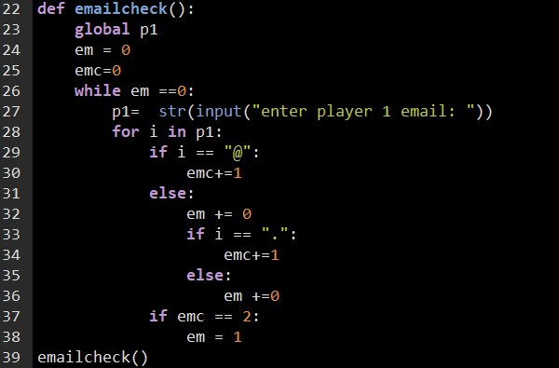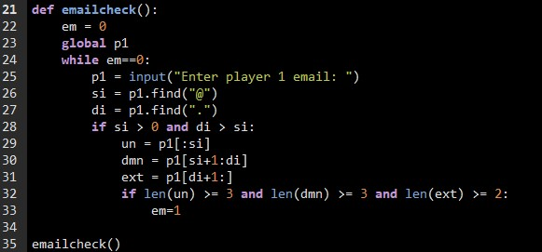
Old function New function
“Draw()” function(to check for draws):
Test Data | Expected result | Actual result | Pass? (y/n)
[[0],[0],[0],[0],[0],[0],[0]] | No draw | No draw | Y
[X,X,X,X,X,X,X] | draw | draw | Y
[S,S,S,S,S,S,S] | draw | draw | Y
[X,S,S,X,X,S,S] | draw | draw | Y
[X,[0],S,X,[0],S,S] | No draw | No draw | y

Conclusion: Function is working as intended, no adjustments needed.
“Horz()” function (To check for horizontal wins):
Test Data | Expected result | Actual result | Pass? (y/n)
[[0],[0],[0],[0],[0],[0],[0]] | No win | No win | Y
[X,X,X,X,X,X,X] | Winner(X) | Winner(X) | Y
[S,S,S,S,S,S,S] | Winner(S) | Winner(S) | Y
[X,S,S,X,X,S,S] | No win | No win | Y
[X,[0],S,X,[0],S,S] | No win | No win | y

Conclusion: Function is working as intended, no adjustments needed.
Black box / white box (System) testing: Other functions such as “wins()”,”vert()”[To check for vertical wins] and “pos()”[To place counter on board] were tested using integration testing as these functions are designed to work together. functions such as “board()” “strategy()”[to initiate the strategy hypotheses], were tested using white and black box testing as they need to be called along side the rest of the game to serve any purpose. The system was tested by my friends and brother using different strategies and game modes, there were no errors found in the functions and no adjustments were needed.
I also validated user inputs by ensuring the code doesn’t crash when an unexpected value is entered, instead the game will ask for the input again until the correct input is received. E.g. if the player enters “2” instead of either “1” or “0”, the while loop will not break and ask again until the condition is met.
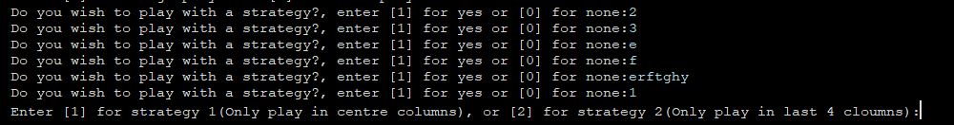
Evaluation
Looking back at my initial design, I concluded that my code has significantly improved and been optimised. The initial design was very unoptimized and would unexpectedly crash due to the length of the code. The code was optimized through the use of functions and classes. I also used “while loops” in order to ensure the programme doesn’t crash if an unexpected value is input into the system. My final design meets the my objects as follows:
- The game is fully interactive, as the players enter their playing positions for every turn. They can choose strategies, gamemodes and it can be played till a winner or draw is declared.
- The game accepts more than 3 inputs such as email addresses, strategy 1 or 2, gamemode and player playing position. If an incorrect input is received, the programme will ask for the correct input again instead of crashing.
- It’s playable in 3 gamemodes, single/multiplayer and simulation (runs 2000 games and tests 2 strategies )
- Data from single and multiplayer, simulation and data analysis is stored in CSV files for comparisons and predictions.
- I have developed algorithms to calculate win rates, average moves and frequency of draws, from the data of simulations of Hypotheses.
- A board is printed after every move taken by players using lists and the “board()” function, to visualise the game and make it more appealing. Along with this, using ANSI colour codes, the text and instructions are easier to understand.
I believe I could’ve improved my code by utilizing even more functions and classes to optimize it further. I could also have implemented a more complex AI that can block and recognize patterns in the game, given additional time. Variable names could also have been more detailed to make the code easier to understand and further expand. (E.g. instead of “cm”, “computerMoves” would be easier to understand). Using more arguments and return values instead of using global variables would help make the code look clean and run smoother.

References
1.“Play 4 in a Line!” Www.mathsisfun.com, www.mathsisfun.com/games/connect4.html.
2. “247 Blackjack.” Www.247blackjack.com, www.247blackjack.com/.
3.“Ludo Online: Play Ludo Online for Free on LittleGames.” Casual Games, gameforge.com/en-US/littlegames/ludo-online/#. Accessed 22 Jan. 2023.
4. Neave Interactive. “Tic-Tac-Toe - Play Retro Tic-Tac-Toe Online for Free.” Tic-Tac-Toe, Tic-Tac-Toe, 2000, playtictactoe.org/.
5. Mueller, JD, Jennifer. “How to Win at Connect 4.” WikiHow, www.wikihow.com/Win-at-Connect-4.

Summary word count
section | Word count
Meeting the brief | 394
Investigation and Plan | 437
Design | 438
Implementation | 466
Testing | 382
Evaluation | 335
Total: | 2452

